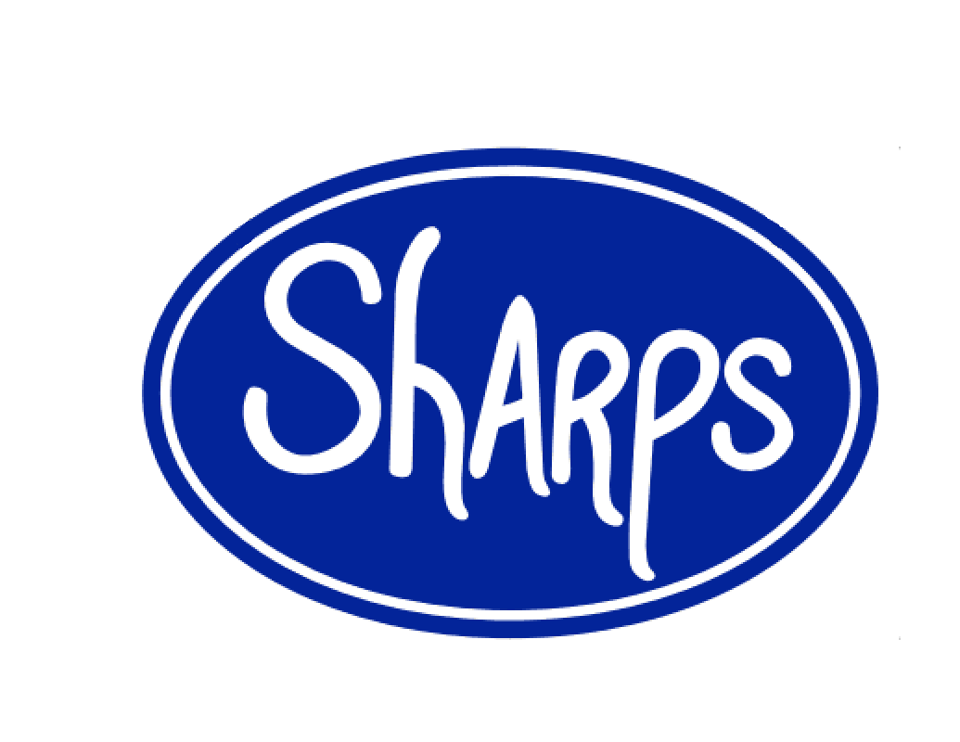
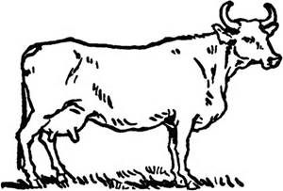

423-928-3826 126 E. Market St. Johnson City, TN 37604 Tuesday-Saturday 11-8 http://sharpsdeli.weebly.com Or facebook.com/Sharpsdeli
Appetizers
- Green Beans: Fried Crispy, served with House Made Ranch. $5.50

- House Made Chips: Fried Fresh, Served Salted. $3

- Crispy French Fries: Cut in House. Salted, served with Ketchup or House Made Ranch. $3 Add Cheese, Chili, or Bacon for $.50 Each.

- Boneless Bites: Plain, Medium, or Buffalo with House Made Blue Cheese and Celery Sticks. $6

- Crispy Onion Rings: Deep fried, served with House Made Horseradish Dipping Sauce or House Made Ranch. $4.50

- Mozzarella Cheese Sticks: Fried to a Crunchy Golden Brown, served with House Made Ranch. $5

- Crispy Fried Button Mushrooms: Deep Fried Golden brown, served with House Made Ranch. $5

- Fresh Pork Rinds: Fried Crunchy, Served Salted or Spicy. $3
Salads House Made Dressings: Ranch, Blue Cheese, Honey Mustard, 1000 Island, Avocado Lime, Fat Free Raspberry Walnut Vinaigrette, Italian and Caesar.
- House Salad: Carrots, Boiled Eggs, Tomato, Cucumber, Shredded Cheese, and Croutons.
Sm. $4 Lg. $5.50

- Caesar Salad: Chopped Romaine, Shaved Parmesan and Croutons. $5.50 Add Seared Chicken for $2.00.

- Chef’s Salad: House Salad with Thinly Sliced Ham, Roasted Turkey, Shredded Cheese, Mozzarella, and Croutons. $8

- House Cobb: Tomatoes, Boiled Eggs, Crispy Bacon, Ham, Grilled Chicken Breast, Blue Cheese Crumbles and Avocado. $9

- Chicken Bacon Avocado: Roasted Chicken Breast, Sliced Avocado, Crispy Bacon, Chopped Boiled Egg, and Tomato. $9
Soups All of our Soups are Made Fresh in House Using as Much Locally Grown Market Sourced ingredient as we can, served with Fresh Baked Bread. Ask your server about our Specials. Cup $3 Bowl $5

- Tomato Bisque: Roasted Tomatoes Blended with Cream and Love. Slightly Spicy.
Sides
- Fries $1.50
- Chips $1.50
- Pork Rinds $1.50
- Onion Rings $1.75
- Green Beans $2.25
- Mushrooms $2.25

All of Our Signature Sandwiches are Served with Fresh House Made Chips and your choice of a Dill Pickle Spear, Bread & Butter or Fire & Ice Pickle Chips.

- Big Beef: Thin Sliced Roast Beef, Double Provolone, Sautéed Onions, and Horseradish Mayo on a Toasted Sub Roll. $8

- Rueben: Corned Beef, Sauerkraut, Swiss, and House made 1,000 Island Dressing on a Toasted Rye Bread. $8

- Deli Style Philly: Shredded Chopped Roast Beef, Sautéed Onions and Green Peppers, Double Provolone, and Mayo on a Toasted Sub Roll. $8

- Italian Beef: Hot Thin Sliced Roast Beef, Spicy Pickled Gardiner, and Italian Seasonings on a Toasted Sub Roll. $8

- Mr. French: Hot Thin Sliced Roast Beef Dipped in Au Jus on a Toasted Sub Roll with Double Provolone and an Extra Cup of Au Jus. $8

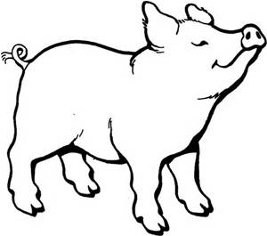
- Classic Pastrami: Thin Sliced Pastrami Piled High with Swiss on a Toasted Pumpernickel Roll with a Smear of House Made Stone Ground Mustard. $8

- The Big Pig: Ham, Crispy Bacon, Swiss, Lettuce, Tomato, Mayo, and House Made Stone Ground Mustard on a Sub Roll. $7.50

- BLT: A Pile of Crispy Bacon, Lettuce, Tomato, and Mayo on Toasted Sliced White Bread. $6

- Genoa: Our Take on a Classic Italian Sub. Genoa Salami, Ham, Provolone, Thin Sliced Fresh Onions and Green Peppers, with House Made Italian Dressing on a Sub Roll. $7.50

- Bologna and Cheese: Simple Classic A Thick Slice Seared Off with American Cheese on White Bread. Your choice of Extras. $4
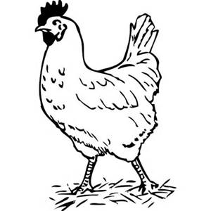
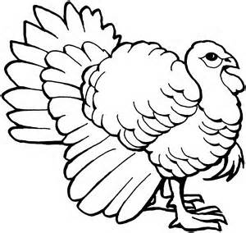

- Rockelle: It’s a Rachael, we just don’t want to call it a Rachael; be cool about it. Roasted Turkey, Swiss, and Fresh Cut Coleslaw on a Toasted Sub Roll. $7

- Gobbler: Roasted Turkey, Smoked Gouda, Crispy Bacon, Lettuce, Tomato, and Mayo on a Toasted Sub Roll. $7.50 Add Sliced Avocado for $1

- Wet Hot American Chicken: Chicken Breast, Sliced Thin and Fried Crunchy, Dipped in Hot Sauce, Topped with Crispy Bacon, Blue Cheese Crumbles and Fresh Cut Coleslaw on a Toasted Sub Roll. $7.50

- Chicken Cobb: Thin Sliced Chicken Breast, Crispy Bacon, Blue Cheese Crumbles, Sliced Boiled Eggs, Lettuce, Tomato, and House Made Ranch on a Toasted Sub Roll. $7.50 Add Sliced Avocado for $1

- Kickin Chicken: Thin Sliced Chicken Breast, Pepper Jack Cheese, Crispy Bacon, Jalapeno Jelly, and a thin Smear of Cream Cheese on a Toasted Sub Roll. $7.50

- Chicken Salad: With Apples, Celery, Grapes, Walnuts, and Mayo on a Flakey Croissant. $7.50

- Grilled Cheese: All Grown Up. American, Provolone, and Swiss Grilled to a Bubbly Golden Brown. $4.50 Add Lettuce, Tomato, and Bacon for $1.50.
- The Alice: Portobello Mushrooms Sliced Thin with Sautéed Green Peppers and Onions, Tomato, Lettuce, and Garlic Mayo. $7.50
- Veggie: A Thin Smear of Cream Cheese, Mushrooms, Cucumbers, Tomato, Lettuce, Pepper Jack, and House Made Italian Dressing. $7.50 Add Sliced Avocado for $1

All served on Sliced White Bread.
- Crunchy Monkey: Banana slices, Peanut Butter, Walnuts and a good Drizzle of Local Honey, Battered and Fried Crunchy. $4.50 Ala Mode Add $1.75.
- Old School PB&J: Smeared on White Bread, Enough Said. $3

- Fluffernutter: Creamy Peanut Butter and Marshmallow Fluff. $3
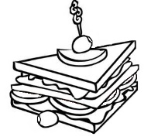

Three Layers of Toasted White Bread Deliciously Filled Then Quartered, Served with a Dill Pickle Spear.
- Classic: Turkey, Ham, Crispy Bacon, Swiss, and American with Lettuce, Tomato, and Mayo. $7

- California: Turkey, Crispy Bacon, and Sliced Avocado with Lettuce, Tomato, and a Drizzle of House Made Ranch. $7.50
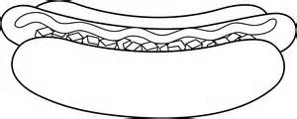

Nathan’s Premium Hot Dogs Cooked Seared Split Open.
- Plain: Simply with Ketchup. $3 Add Fresh Cut Coleslaw for $.50

- Bacon Cheddar: Shredded Cheddar and Crispy Bacon. $4

- Loaded: With Chili, Diced Onions, Shredded Cheddar, Yellow Mustard, Ketchup and Fresh Cut Cole Slaw. $4.50

Extras Customize for Free Shredded Lettuce, Tomato, Onion, Diced Onion, Mayo, Yellow Mustard, Pickle Relish, or Ketchup. Premium Extras For $.50: Sliced Pickled Jalapenos, Cream Cheese, Cucumbers, Sautéed Onions & Green Peppers, Sautéed Mushrooms, Fresh Green Pepper, Dill Pickle Spear, Bread & Butter or Fire & Ice Pickle Chips, Any House Made Salad Dressing, Hell Sauce, or Fresh Cut Coleslaw. For $1: Crispy Bacon, Sliced Avocado, Jalapeno Jelly, or Blue Cheese Crumble Filled Coleslaw.
Drinks Ask Your Server for a Current List of Bottle & Draft Beers
Fountain Drinks
- Coke, Diet Coke, Sprite, Mellow Yellow, Mr. Pibb, Pink Lemonade, Sweet or Un-Sweet Tea $1.75 Coffee $1

Build Your Own Create Your Perfect Sandwich. Cooked either Grilled, Steamed, or Cold. Comes with House Made Chips and your choice of pickles. $7.50

- Choose a Bread: Fresh Sub Roll, Dark Pumpernickel Roll, Sliced Rye, Croissant, Whole-Wheat Wrap or Sliced White Bread.

- Choose up to Two Meats: Roast Beef, Turkey, Ham, Salami, Corned Beef, Pastrami, Bologna or Sliced Grilled Chicken Breast (counts as 2 meats). Grilled Portobello Cap also available.

- Choose a Cheese: American, Swiss, Pepper Jack, Provolone, Muenster, Smoked Gouda, or Smoked Cheddar.

- Extras: Shredded Lettuce, Tomato, Onion, Mayo, Yellow Mustard, or Ketchup. Premium Extras For $.50: Sliced Pickled Jalapenos, Cream Cheese, Cucumbers, Sautéed Onions & Green Peppers, Sautéed Mushrooms, Fresh Green Pepper, Dill Pickle Spear, Bread & Butter or Fire & Ice Pickle Chips, Any House Made Salad Dressing or Fresh Cut Coleslaw. For $1: Crispy Bacon, Sliced Avocado, Jalapeno Jelly, or Blue Cheese Crumble Filled Coleslaw.
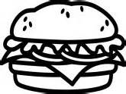

Our Burgers are 1/3 lb. Hand Made Prime Angus Beef Served on a Toasted Bun with French Fries.
- House Burger: 1/3 lb Hand Made Prime Angus Beef Topped with American Cheese, Lettuce, Tomato, Onion, Mayo, and a Dill Pickle Spear on the side. $6.50 Add Bacon for $1.00.

- B&B Burger: Topped with Blue Cheese Crumbles, Crispy Bacon, Lettuce, Tomato, and Mayo. $7

- Mushroom Swiss Burger: Topped with Sliced Sautéed Portobello Mushrooms, Onions, Swiss, and Mayo. $7

- Barnyard Burger: House Burger with All the Toppings, Plus Crispy Bacon and an over easy Fried Egg. $7.50

- Spicy Burger: Topped with Sliced Pickled Jalapenos, Pepper Jack Cheese, Lettuce, Tomato, and Mayo. $7 Crank up the Heat with a side of Hell Sauce for $.50

- Portobello Burger: Grilled Portobello Cap with Lettuce, Tomato, Onions, Mayo and Provolone Cheese. $7.50 Add Avocado for $1

Desserts Ask your server about our Weekly Specials, made in House Using as much Locally Grown Market Sourced Ingredients as we can, Season Permitting.
- Ice Cream: Vanilla or Chocolate, $1.75 per scoop, Free Drizzle of Butterscotch or Chocolate Sauce.

- Traditional New York Egg Cream: Made with Fox’s u-bet syrup, Soda Water, and Milk. $2.50

- Milkshakes: 16oz. of Deliciousness. Your choice of Vanilla or Chocolate Ice Cream. $3 Additions $.50 each. Peanut Butter, Walnuts, Bananas, Walnuts and Honey, Nutella.

Cans
- Coke, Diet Coke, Sprite $.75
- Bottled Water $1
- Red bull $2.50
- NOS $2.00

