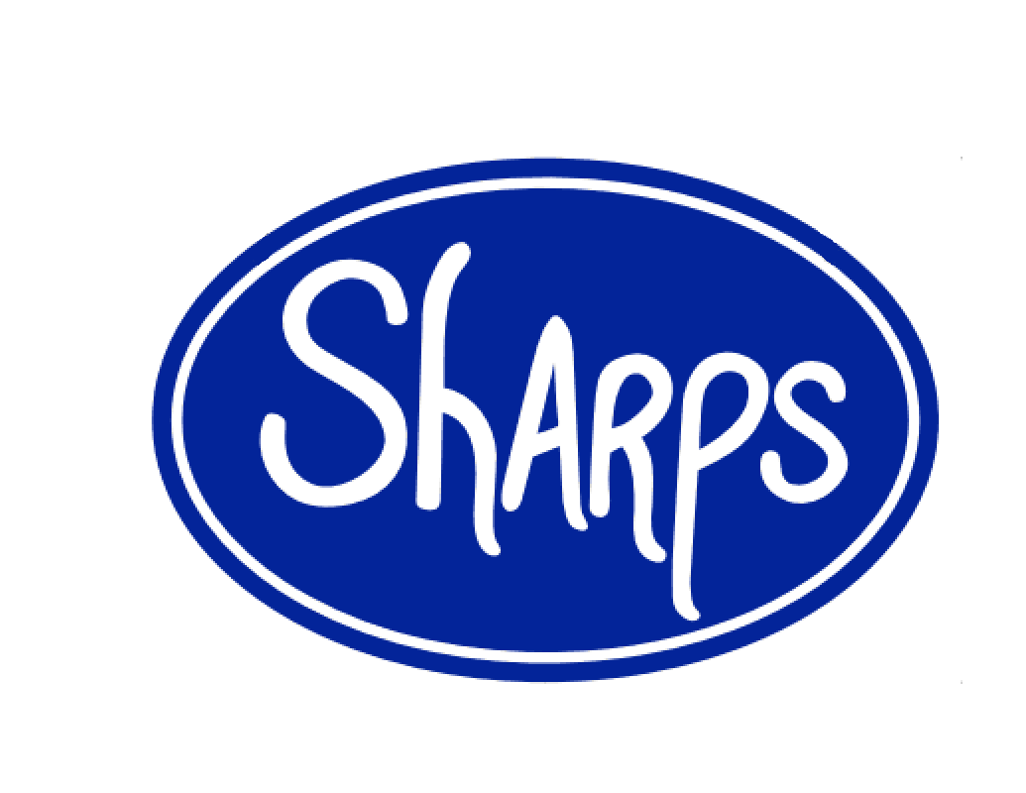
126 E. Market St. Johnson City, TN 37604 423-928-3826 https://sharpsdeli.weebly.com 24 Hour/ Day Before Notice Needed please. We can go off menu to suite your needs, simply inquire, we’re flexible.
Trays
- Fresh Fruit: Variety of Fresh Cut Fruit. Served with Our House Made Creamy Strawberry Dip. We Use Locally Grown Strawberries; Fresh in Season and Preserved for Off Season. Sm $38 serves 10-20 M $56 serves 20-30 Lg $75 serves 30-40.

- Fresh Fruit and Cheese Cubes: Our Traditional Fresh Fruit Tray with Our House Made Strawberry Fruit Dip alongside Perfect Little Cubes of Sharp Cheddar, Mild Mozzarella, Marbled Colby, and Pepper Jack. Sm $45 serves 10-20 M $62 serves 20-30 Lg $80 serves 30-40.

- Garden Veggies: A Variety of Fresh Cut Garden Veggies Served with House Made Ranch. Sm $35 serves 10-20 M $45 serves 20-30 Lg $55 serves 30-40

- Basic Sandwich: Choose a Meat: Black Angus Roast Beef, Honey Ham, Fresh Roasted and pulled Turkey, or Seared and Shredded Chicken. Choose a Cheese: American, Swiss, or Provolone. On Your Choice of Toasted Sub Roll, Toasted Pumpernickel Sub Roll, Old School Sliced White or Wheat Bread, or Flaky Croissant with Lettuce, Tomato and a thin smear of mayo. Mustards available upon request. Choice of Dill Pickle Spears, Bread & Butter, or House Made Fire & Ice. Servings Based on Sandwiches Cut in Half, but can be Quartered, Your Choice. Sm $60 serves 8-12 M $85 serves 12-16 Lg $110 serves 16-20

- Signature Sandwich: Choose Any of Our Signature Sandwiches Listed Below; as they are or on your choice of Bread. Served Sliced in Half with your Choice of Dill Pickle Spears, Bread & Butter, or Fire & Ice Chips. Sm $75 serves 8-12 M $100 serves 12-16 Lg $130 serves 16-20

- Deli Meats: Indulge Your Inner Carnivore. Customize your Perfect Deli Tray, we’ll build it to suit your needs. Choose from Honey Ham, Black Angus Roast Beef, Roasted and Pulled Turkey, Genoa Salami, Cured Pastrami, and Corned Beef, all Rolled up and Fanned out. Add Horseradish Dip or Stone Ground Sweet & Spicy Mustard for $2 Sm $40 serves 10-14 M $55 serves 14-18 Lg $70 serves 18-22

- Deli Meats & Cheese: Our Awesome Deli Meats Tray Accompanied by Sliced American, Swiss, Provolone, and Pepper Jack. Add Horseradish Dip or Stone Ground Sweet & Spicy Mustard for $2 Sm $45 serves 10-14 M $60 serves 14-18 Lg $75 serves 18-22

- Build your own sandwich: Our Deli Meats and Cheese tray with Lettuce Tomato and Onion, Mayo and Yellow Mustard, and your Choice of up to Two Breads. Stone Ground Mustard Available upon Request. Sm $65 serves 8-12 M $90 serves 12-16 Lg $115 serves 16-20

- Cookies: Fresh Baked Deliciousness. Made in House from Scratch Using Premium Ingredients. Choose from: Chocolate Chip, Peanut Butter, Simply Sugar, Oatmeal Raisin, and White Chocolate Macadamia Nut. Build your Perfect Dessert Tray; Choose any Assortment, as Many as You Need. $8 Per Dozen.

- Brownies: Ooie Gooie Goodness. Choose from Decadent Chocolate, Classic Blondie, Chocolate Chip -Walnut Blondie Bombshells, Chocolate Peanut Butter Chip, and Chocolate Walnut. Design and Build the Perfect Dessert Tray; Choose any Combination, as Many as You Need. $14 Per Dozen

Signature Sandwiches
- Big Beef: Thin Sliced Roast Beef, Double Provolone, Sautéed Onions, and Horseradish Mayo on a Toasted Sub Roll.

- Rueben: Corned Beef, Swiss, and House made 1,000 Island Dressing on a Toasted Pumpernickel Roll. Sauerkraut is Served on the Side to Prevent Sogginess.

- Deli Style Philly: Shredded Chopped Roast Beef, Sautéed Onions and Green Peppers, Double Provolone, and Mayo on a Toasted Sub Roll.

- Italian Beef: Hot Thin Sliced Roast Beef, Spicy Pickled Giardiniera, and Italian Seasonings on a Toasted Sub Roll.

- Classic Pastrami: Thin Sliced Pastrami Piled High with Swiss on a Toasted Pumpernickel Roll with a Smear of House Made Stone Ground Mustard.

- The Big Pig: Ham, Crispy Bacon, Swiss, Lettuce, Tomato, Mayo, and House Made Stone Ground Mustard on a Toasted Sub Roll.

- BLT: A Pile of Crispy Bacon, Lettuce, Tomato, and Mayo on Toasted Sliced White Bread.

- Italian: Genoa Salami, Ham, Provolone, Thin Sliced Fresh Onions and Green Peppers, with House Made Italian Dressing on a Toasted Sub Roll.

- Rockelle: It’s a Rachael, we just don’t want to call it a Rachael; be cool about it. Turkey, Swiss, and Fresh Cut Coleslaw on a Toasted Sub Roll. Coleslaw is Served on the Side to Prevent Sogginess.

- Gobbler: Turkey, Muenster Cheese, Crispy Bacon, Lettuce, Tomato, and Mayo on a Toasted Sub Roll. Add Sliced Avocado for $1

- Wet Hot American Chicken: Chicken Breast, Sliced Thin and Fried Crunchy, Dipped in Hot Sauce, Topped with Crispy Bacon on a Toasted Sub Roll. Blue Cheese Crumble Filled Coleslaw Served on the Side to Prevent Sogginess.

- Chicken Cobb: Thin Sliced Chicken Breast, Crispy Bacon, Blue Cheese Crumbles, Sliced Boiled Eggs, Lettuce, Tomato, on a Toasted Sub Roll with a Side of House Made Ranch. Add Sliced Avocado for $1

- Kickin Chicken: Thin Sliced Chicken Breast, Pepper Jack Cheese, Crispy Bacon, Jalapeno Jelly, and a thin Smear of Cream Cheese on a Toasted Sub Roll.

- Chicken Salad: With Apples, Celery, Grapes, Walnuts, and Mayo on a Flakey Croissant.
- The Alice: Portobello Mushrooms Sliced Thin with Sautéed Green Peppers and Onions, Tomato, Lettuce, and Garlic Mayo.
- Veggie: A Thin Smear of Cream Cheese, Mushrooms, Cucumbers, Tomato, Lettuce, Pepper Jack, and House Made Italian Dressing. Add Sliced Avocado for $1

Boxed Lunches
- Basic Box: Choose a Meat: Black Angus Roast Beef, Honey Ham, Fresh Roasted and pulled Turkey, or Seared and Shredded Chicken. Choose a Cheese: American, Swiss, or Provolone. On Your Choice of Toasted Sub Roll, Toasted Pumpernickel Sub Roll, Old School Sliced White or Wheat Bread, or Flaky Croissant with Lettuce, Tomato and a thin smear of mayo. Mustards available upon request. Choice of Dill Pickle Spears, Bread & Butter, or House Made Fire & Ice. Served with Chips and a Scratch Made Chocolate Chip or Simply Sugar Cookie. $8
- Signature Box: Choose Any of Our Signature Sandwiches Listed Above; as they are or on your choice of Bread. Served Sliced in Half with your Choice of Dill Pickle Spears, Bread & Butter, or Fire & Ice Chips. Served with Chips and a Scratch Made Chocolate Chip or Simply Sugar Cookie. $10
Salads Priced as a Personal Salad. Large Party Sizes Available Upon Request. House Made Dressings: Ranch, Blue Cheese, Honey Mustard, 1000 Island, Avocado Lime, Fat Free Raspberry Walnut Vinaigrette, Italian, Balsamic Vinaigrette and Classic Caesar.
- House Salad: Carrots, Boiled Eggs, Tomato, Cucumber, Cheddar Cheese, and Croutons.
Sm. $4 Lg. $5.50

- Caesar Salad: Chopped Romaine, Shredded Parmesan and Croutons. $5.50 Add Seared Chicken for $2.00.

- Chef’s Salad: House Salad with Thinly Sliced Honey Ham, Roasted Turkey, Shredded Cheddar Cheese, Mozzarella, and Croutons. $8

- House Cobb: Tomatoes, Boiled Eggs, Crispy Bacon, Honey Ham, Grilled Chicken Breast, Blue Cheese Crumbles and Avocado. $9

- Chicken Bacon Avocado: Roasted Chicken Breast, Sliced Avocado, Crispy Bacon, Chopped Boiled Egg,
Tomato, and Onion. $9

- Chicken Salad-Salad: A Large Scoop of Our House Made Chicken Salad with Apples, Celery, Grapes and Walnuts on top of Green Leaf Lettuce with Chopped Tomatoes. Crackers Available upon Request. $9

Soups All of our Soups are Made Fresh Daily in House Using as Much Locally Grown Market Sourced Ingredients as we can, served with Fresh Baked Bread or Saltines. Ask your server about our Weekly Specials. Personal 8oz. Bowl $5 Quart $14 serves 3-4 ½ Gal $28 serves 6-8 Gal. $55 serves 12-16
- Tomato Bisque: Roasted Tomatoes Blended with Heavy Cream and Love. Slightly Spicy.

- Chili: Beef, Onions, Tomatoes, Beans, and a Variety of Fresh and Dried Peppers, Stewed to Perfection.

- Broccoli Cheddar: Florets Chopped and Simmered Tinder in a Creamy Cheddar Cheese Sauce.

Drinks
- Fresh House Made Lemonade: Hand Squeezed Every Morning to ensure Freshness and Quality. $3 ½ Gal $5 Gal

- Fresh House Made Tea: Freshly Brewed Available as Sweet, Unsweet, or Strawberry. $3 ½ Gal $5 Gal

- Cans of Coke, Diet Coke, Sprite $1 Bottled Water $1 Red bull $2.50 NOS $2
Build Your Own in a Box Create Your Perfect Lunch Combo. Comes with your choice of pickles, a Bag of Chips, Fresh Baked Chocolate Chip or Sugar Cookie. $9 Add any Premium Deli Side For $2
- Choose a Bread: Fresh Sub Roll, Pumpernickel Sub Roll, Rye, Croissant, Whole-Wheat Wrap, Sliced White or Wheat Bread.

- Choose up to Two Meats: Roast Beef, Turkey, Ham, Salami, Corned Beef, Pastrami, Bologna or Sliced Grilled Chicken Breast (counts as 2 meats). Grilled Portobello Cap also available.

- Choose a Cheese: American, Swiss, Pepper Jack, Provolone, Muenster, Smoked Gouda, or Smoked Cheddar.

- Extras: Shredded Lettuce, Tomato, Onion, Mayo, Yellow Mustard, or Ketchup.
- Premium Extras For $.50: Sliced Pickled Jalapenos, Cream Cheese, Cucumbers, Sautéed Onions & Green Peppers, Sautéed Mushrooms, Fresh Green Pepper, Dill Pickle Spear, Bread & Butter or Fire & Ice Pickle Chips, Any House Made Salad Dressing or Fresh Cut Coleslaw.

For $1: Crispy Bacon, Sliced Avocado, Jalapeno Jelly, or Blue Cheese Crumble Filled Coleslaw.

Premium Deli Sides
  - Fresh Pork Rinds: Fried Crunchy, Served Salted or Spicy. $2 Personal $4 Bag

  - House Made Baked Potato Salad: A Delicious Mixture of Potato, Shredded Cheddar Cheese. Crispy Bacon, and Sour Cream. Garnished with Green Onions. $2 Personal $4 a LB

  - Fresh Cut Coleslaw: Made in House Daily $2 Personal $4 a LB

  - Fresh Fruit: A Personal Portion of Fresh Cut Fruits $2.50 Personal $5.50 a LB

  - House Made Pasta Salad: Our Take on a Classic, with Grape Tomatoes, Onion, and Bell Pepper. $2 Personal $4.50 a LB

  - House Made Asian Noodle Salad: Crunchy Goodness. Shredded Broccoli, Red Onion, Carrots, Sunflower Seeds, Ramen Noodles, Green Onions, and Almonds Tossed in House Made Ginger Soy Dressing. $2.50 Personal $5.50 a LB

  - Deviled Eggs: Made Fresh in House the Morning of the Order. Simply with Mayo and a smidge of Mustard. Tell us if you want Diced Pickles Added. Garnished with Slightly Smokey Paprika. $2.25 Personal (3) $9 a Dozen

